Major Flood Occurrence Modelling for Nata, Botswana
Kelly Masoto^{a*} , Easther Mosase^{b}
^{a,b}Botswana International University of Science and Technology, Palapye, Botswana
ªEmail:masoto.kelly@studentmail.biust.ac.bw
^{b}Email:mosasee@biust.ac.bw

Abstract
For an accurate assessment of flood risk, taking into account the relationship between heavy rainfall and storm surge can be crucial. There are several statistical techniques for modeling such severe dependence, but it is unknown how well they function in terms of calculating the probability that infrequent river floods will exceed a given threshold. The Gumbel mixed model, a bivariate extreme value distribution model with Gumbel marginals, is suggested in this research in order to explore the joint probability distribution of connected flood peaks and volumes as well as the joint probability distribution of correlated flood volumes and durations. The joint distributions, conditional probability functions, and appropriate return periods are obtained from the marginal distributions of these random variables. This study examines how the Gumbel distribution equation model and rainfall data set can be utilized to analyze flood frequency and flood extreme ratio of any given spatial domain in order to underline the significance of employing the model in the geo-analysis of diverse environmental phenomena. For the building of water projects in ungauged locations without records of rainfall intensity or climate conditions, it is essential to produce suitable rainfall Intensity-Duration-Frequency (IDF) curves. Hydrological engineering planning, design, and management problems frequently call for a thorough understanding of flood event characteristics, such as flood peak, volume, and duration. Flood frequency analysis often focuses on flood peak values and so provides a limited assessment of flood events. This study looked at a 31 years span of rainfall data and found out that according to the gumbel distribution annual precipitation of 63.28mm is most likely to occurevery year, and annual precipitation of 300.59mm has a 100% chance of occurring every 32 years. It can be deduced from the graphs that there is 3% of 301 mm rainfall occurrence. The lower percentage exceedance probability of 97% shows that there are higher chances of having 63mm. This method is appropriate for estimating discharge while designing flood control structures.
Keywords: Gumbel’s distribution; flood frequency analysis; intensity duration frequency curves.
------------------------------------------------------------------------
Received: 10/2/2023
Accepted: 12/1/2023
Published: 12/10/2023
------------------------------------------------------------------------
* Corresponding author.
- Introduction
It is difficult to create an effective water project design since rainfall in arid places is typically unpredictable and inconsistent in both time and space. The lack of observations in many rainfall and runoff stations complicates the enormous spatial and temporal rainfall variability, necessitating the use of empirical and statistical methodologies. Flood frequency analysis (FFA) is most commonly used by engineers and hydrologists worldwide and basically consists of estimating flood peak quantities for a set of non-exceedance probabilities. Flood frequency analysis involves the fitting of a probability model to the sample of annual flood peak recorded over a period of observation, for a catchment of a given region. The model parameters established can then be used to predict the extreme events of large recurrence interval.
How severe a flood is also depends on other aspects of the extreme event, such as its volume and duration, in addition to the flood peak value. In actuality, a flood event can be described as a multivariate event, with its three main characteristics being its peak, volume, and duration, all of which are interconnected. Flood frequency studies have, however, usually concentrated on the analysis of flood peaks (or magnitudes). This study seeks to address a gap in the literature by investigating flood frequency analysis in Botswana. Flood frequency analysis assumes that yearly maximum floods are passive, independent random processes with a uniform distribution in the way that it is normally employed. Annual maximum floods, however, are dynamic in the context of climate change [1].
Most water engineering projects call for rainfall intensity estimations, notably IDF curves for the various return periods. By utilizing the appropriate statistical distributions based on previous rainfall data, IDF curves can be produced. Long-term records make it possible to more accurately estimate rainfall depth and intensity, which is essential for water projects. The topic of rainfall frequency and the associated IDF curve developments for arid regions of the world have been examined by numerous scholars. Other experts in the fields of hydrology and engineering have developed IDF curves for both arid and non-arid regions of the world. [2], for instance, derived IDF equations for specific Saudi Arabian locations. Using iso-pluvial maps and techniques for rainfall frequency, IDF curves have been updated for ungauged sites in the eastern United States. In Malaysia, ungauged areas are fitted with IDF curves using data from nearby meteorological stations that have been biased-corrected within the expected range [3].
For instance, with this method, floods every ten, twenty, fifty, and one hundred years can be predicted. The Gumbel curve and other statistical frequency curves for floods, which provide precise estimates of the frequency of floods and are crucial for managing floodplains and for the protection of the public when designing dams, bridges, culverts, highways, and industrial structures, make it possible to make these forecasts [4]. The total amount of precipitation is used for the analysis of Nata's flood frequency because the frequency of extreme precipitation is positively correlated with the total amount of precipitation and Nata is more frequently affected by flash floods than other types of floods. As a result, extreme precipitation becomes the major contributor.

- Literature Review
Any water resources project that involves flood control must estimate future hydrologic events, such as rainfall depth, flow depth, discharge, and gauge level. The movement of water along the watershed as a result of precipitation is the subject of surface water hydrology. Flood, however, is fundamentally a random occurrence. Therefore, it is challenging to determine the precise maximum flood that could occur in the future [5]. Heavy rains have an impact on both river floods (seasonal flooding) and floods caused by tropical cyclones (flash floods). Seasonal precipitation over a sizable catchment area causes river floods. Tropical storms produce enormous amounts of rainfall that are too much for streams and rivers to handle, resulting in flash floods [6].
It is crucial for nations to consider the likelihood, magnitude, frequency, and probable return periods of a certain flood magnitude in order to help with planning and the development of the nation's infrastructure as well as during the recovery phase of the disaster management cycle. According to [4], flood frequency analysis seeks to relate the size of an event (a flood) with the frequency or likelihood that it is exceeded. Flood frequency analysis can be used to anticipate significant floods with a broad recurrence interval by evaluating how frequently a specific occurrence will occur [4].
Frequency analysis studies abound in hydrological literature. The first phase in the hydrological evaluation is to determine the projected floods as a result of one or more rainfall events. The intensity-duration frequency (IDF) curves for the local rainfall are typically used for this. Here, a synopsis of the Flood Frequency Analysis (FFA) is written, along with examples from several types of frequency analysis. After that, analyze the frequency of non-stationary floods while accounting for upcoming urbanization and climate change [3].
To come up with these IDF for FFA many studies have been carried out around the world using statistical distributions. Gumbel distribution is a statistical technique frequently used for forecasting extreme hydrological events, such as floods, according to [7] analysis of the flood frequency factor for the Gumbel distribution using regression and the GEP model. Because peak flow data are homogeneous, independent, and devoid of long-term trends, and because the river under study is less regulated and has flow data going back more than ten (10) years, [7] employed the Gumbel Distribution for flood frequency analysis. The following mathematical formula is the equation for fitting the Gumbel distribution to observed series of flood flow at various return periods T:
$Qt = Q + Kα$ (1)
Where QT denotes the magnitude of the T-year flood event, K is the frequency factor, Q and a are the mean and standard deviation of the maximum instantaneous flows, respectively.
The Gumbel distribution is a popular method used in hydrology for predicting the frequency and probability of floods. It is widely used due to its simplicity and effectiveness in fitting extreme value distributions to hydrological data. In this literature review, we will summarize and discuss several studies that have utilized the Gumbel distribution to predict flood frequency and probability.
One of the earliest studies on this topic was conducted by Gumbel himself in 1954, where he proposed a statistical method for predicting extreme values in hydrology. The study showed that the Gumbel distribution can effectively fit maximum annual floods in several rivers in the United States.
In a study conducted by [10], the Gumbel distribution was used to estimate the frequency and probability of floods in several rivers in Quebec, Canada. The study showed that the Gumbel distribution provided a good fit to the data, and the estimated flood frequencies were consistent with historical flood events.
Similarly, in a study conducted by [11], the Gumbel distribution was used to predict flood frequency in the Godavari river basin in India. The study found that the Gumbel distribution provided a good fit to the data, and the estimated flood frequencies were consistent with historical flood events.
In another study conducted by [12], the Gumbel distribution was used to predict flood frequency in the Yangtze River basin in China. The study showed that the Gumbel distribution provided a good fit to the data, and the estimated flood frequencies were consistent with historical flood events.
A more recent study conducted by [13] used the Gumbel distribution to predict the frequency and probability of floods in the Karoon River basin in Iran. The study found that the Gumbel distribution provided a good fit to the data, and the estimated flood frequencies were consistent with historical flood events.
Overall, the studies reviewed demonstrate the effectiveness of the Gumbel distribution in predicting flood frequency and probability. The simplicity and reliability of the Gumbel distribution make it a valuable tool for hydrologists and engineers involved in flood risk management and planning. However, further research is needed to explore the applicability of the Gumbel distribution in other regions with different climatic conditions, and to compare its performance with other methods for predicting flood frequency and probability.
2.1 Validation
There are several ways you could validate the Gumbel distribution method for analyzing flood data:
Comparison with historical flood data: One way to validate the method is to compare the estimated flood magnitudes and frequencies with historical flood data in the region of interest. If the estimated values match well with the observed values, then it provides evidence that the Gumbel distribution is an appropriate method for analyzing the flood data. This is the method used in this study to validate the results.
Sensitivity analysis: Another way to validate the method is to test how sensitive the estimated flood magnitudes and frequencies are to changes in the input data. For example, you could randomly sample different subsets of the input data and test whether the estimated flood values change significantly. If the estimated values are relatively stable across different subsets of the input data, then it provides evidence that the Gumbel distribution is a robust method for analyzing the flood data.
Comparison with alternative methods: Finally, you could compare the Gumbel distribution method with alternative methods for analyzing flood data, such as the Weibull distribution or the Log-Pearson Type III distribution. If the Gumbel distribution performs better than these alternative methods in terms of accurately estimating flood magnitudes and frequencies, then it provides further evidence of the validity of the method.
2.2 Flooding in Nata
When a river's capacity is exceeded by its flow rate, particularly near bends or meanders in the waterway, floods can also happen. If they are located in the natural flood plains of rivers, homes and businesses are frequently damaged by floods. People have historically lived and worked by rivers because the ground is typically flat and productive and because rivers offer easy transport, access to trade, and industry. However, riverine flood damage can be reduced by moving away from rivers and other bodies of water.
- claims that from 2010 to 2015, Tutume Sub-District, where Nata is situated, saw more severe flood damage than other districts. The 2013 floods devastated 446 families and resulted in 1,489 individuals being evicted from their houses in Tutume Sub-District alone. As a result, 218 food baskets and 400 tents were sent to the victims as aid. The following towns and cities in the Tutume Sub-District were impacted by the flooding: Nata, Sowa Town, Matsitama, Dukwi, Mosetse, Marapong, Zoroga, Tutume, Goshwe, Maposa, and Makoba. These are referred to as "flash floods" by the National Disaster Management Organization of Botswana. In table 1, the author [1] summarised the history of floods that have been recorded in Botswana, along with their rainfall intensity and damage observed.
DATE | INTENSITY OF PRECIPITATION (monthly rainfall totals in mm) | Damage observed
1972(January) | 257.4 | US$50 economic loss
1988(Fevruary) | 254.4 | 8 Deaths; 12007 people affected
1995(March) | 179.6 | 20 Deaths; 5500 people affected
2000(February) | 276.7 | 3 deaths; 138276 people affected; US$2000 economic loss
2010(January) | 123.3 | Data unavailable
2012(January) | 108 | Data unavailable
2013(December) | 118.7 | 12 deaths
2015(January) | 80.6 | Data unavailable
2017(February) Cyclone Dineo | 170.8 | 650 households affected; 500 houses destroyed; bridges collapsed; roads closed
Table 1: History of floods in Botswana [1]

- Study Area
  - Location
The Makgadikgadi Pans are located in north-eastern Botswana, south east of the Okavango Delta and south of the Chobe River front, both of which are major tourism centres in northern Botswana. The catchment area of the Makgadikgadi Pans is larger and extends into Zimbabwe in the east and north through the Nata River system. It is also linked to the Okavango system on the north-western side through the Boteti River. The wetland area is divided into the eastern Sua Pan and western Ntwetwe Pan. Each pan has a different catchment area, and they are both covered under the SADC Shared Water Courses Protocol.
The Nata River and the Mosetse, Semowane, Lepashe, and Mosupe Rivers in the Makgadikgadi Basin's eastern region provide inputs to the eastern Sua Pan basin. This part of the Pans is the study ’s area of interest. The map below shows the geographical location of the study are in relation to the country as a whole. Since this western part of the Makgadikgadi has several river systems mentioned above, the author decided to focus on a single system to avoid cumbersome work which might lead having an impossible objective for the given time of study. The Nata river system is the main study area, figure 1.
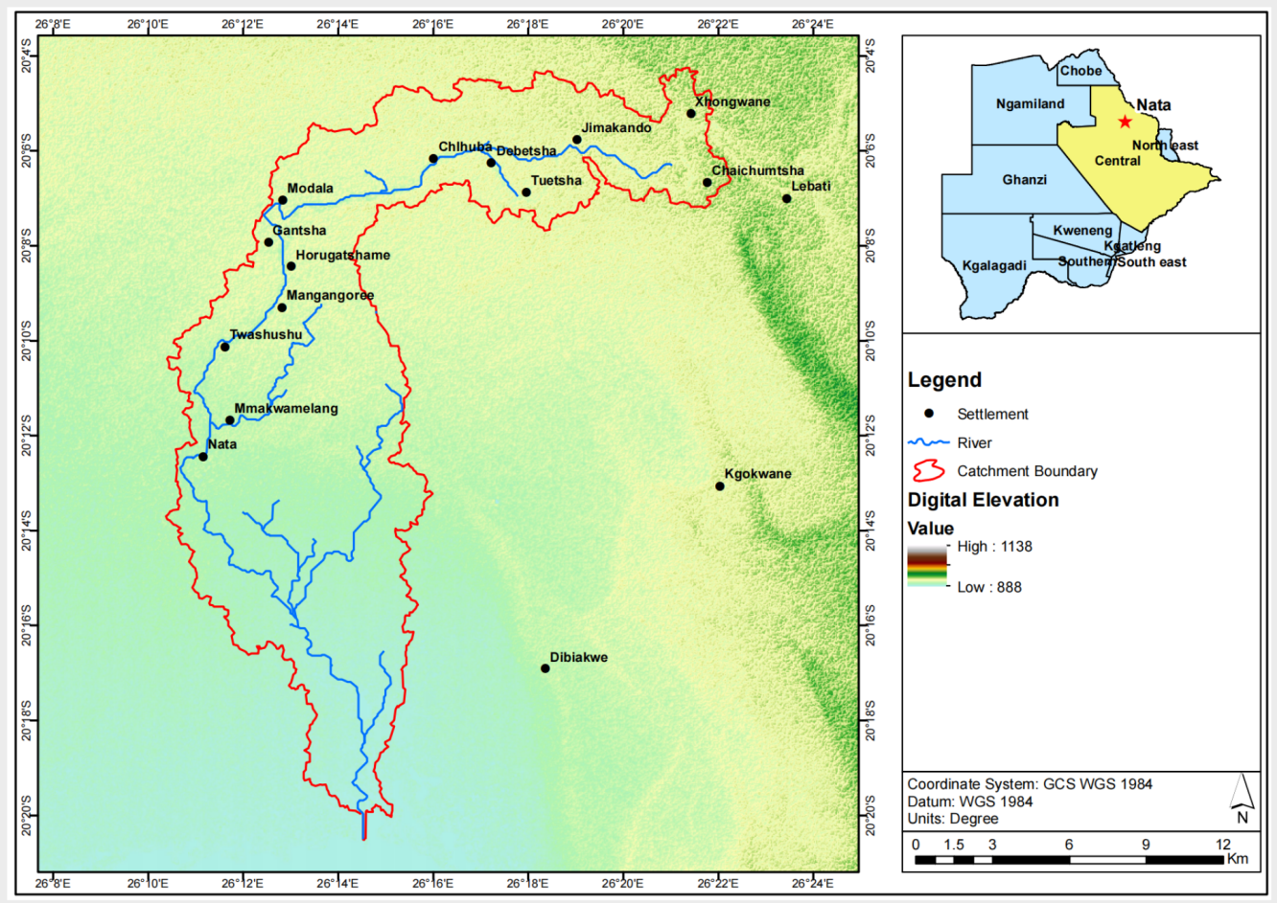Figure 1: Study area map
  - Rainfall
The rainy season in Botswana runs from October to March, with localised variations in rainfall. Rainfall is unexpected and unreliable since it is not precisely known when (on what date) it should start to rain and how much of it will come [8]. Precipitation in the country ranges from 250 mm to 550 mm on average. Figure 2 makes it evident that Nata rainfall is predictable and does not follow any trend from the year 1990 to 2020. Peaks in the figure are related to the flooding history tabulated in table 1.
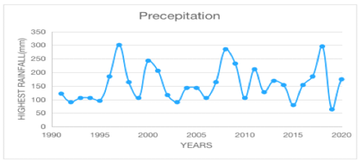
Figure 2: Nata’s highest rainfall records from 1990 to 2020
- Methodology
The extreme value distribution, also referred to as Gumbel's distribution, was first described by Gumbel in 1941. It is frequently used in hydrologic and meteorological studies to forecast the height of floods, the amount of rainfall, and other variables. According to Gumbel, a flood is defined as the largest of the 365 daily flows, and the annual series of flood flows is a collection of the highest values of flows. This theory of extreme occurrences states that the likelihood of an event occurring is equal to or greater than a value $x_{\underline{0}}$. It is employed to calculate the frequency factor at various return intervals. The following is the equation for Gumbel's Distribution with return period T.
$$P = \frac{m}{N + 1}$$ (2)
Where m= order number of the event and N= total number of events in the data. The recurrence interval, T (also called the return period or frequency) is calculated as.
$$T = \frac{1}{P}$$ (3)
$$K = \frac{Y_{t} -{\overline{Y}}_{n}}{S_{n}}$$ (4)
where,
$Y_{t}$ is reduced variate:
$$Y_{t} = -\left[\ln{.\ln\left(\frac{T}{T - 1}\right)}\right]$$ (5)
${\overline{Y}}_{n}$ and $S_{n}$ are selected from Gumbel’s extreme volume distribution table considered depending on sample size (n). These are the equations that are used to calculate the estimated flood magnitude based on a particular return and an overall annual flood series.
  - Steps involved in the methodology
Step I: the annual peak flood is found in the daily data for a period of time.
Step II: from series of annual maximum flood (step I) for n years the mean and are computed using
$\overline{X} = \frac{1}{n }\sum_{i =1}^{n}{x_{i}}$ (6)
Step III: In the Gumbel’s extreme value distribution table, the and values are obtained depending on sample size (n).
Step IV: from the expected return period , the reduced variate is computed using equation (3).
Step V: Flood frequency function K is computed using equation (4), given , and .
Step VI: based on equation (1), the magnitude of flood is computed.
It is crucial to determine whether the input flood data series representing the catchment region satisfies the Gumbel's distribution before using this method for flood frequency analysis [5, 6]. To do this, the return period for each flood is allocated and the observed data is organized in descending order (from highest to lowest). Equation is used to calculate the reduced variate corresponding to each flood (2). A graph showing the relationship between the reduced variate and the flood magnitude is presented; if the plot indicates a straight line, it is acceptable to assume that the observed flood data follows the Gumbel's distribution and is a good fit.
- Results and discussion
N | 31 Years
Mean | 158.2
Standard deviation | 64.1
$$Y_{m}$$ | 0.54
$$S_{m}$$ | 1.1
The nature of data is rainfall depth (mm) recorded every month of the year, the maximum yearly values were used for the purpose of analysis. The summary of peak yearly data is presented in the table 2 below.
Table 2: Gumbel variables

  - Flood frequency analysis
This study evaluated the flood trends at a Nata rainfall station. Figure 3 uses annual maximum rainfall data from the period of 1991 to 2021, a 31-year span, to indicate the estimated magnitude and frequency of rainfall events at the site. The precipitation magnitude-frequency curve indicates that annual precipitation of 63.28mm is most likely to occurevery year, and annual precipitation of 300.59mm has a 100% chance of occurring every 32 years. High-magnitude rainfall events typically have extended return intervals or high recurrence rates but low occurrence rates.
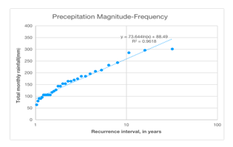
Figure 3: Total rainfall magnitude-frequency graph for Nata
  - Probability of occurence
This section presents observed trends for probability of flood occurrences at Nata rainfall station. Figure 4 represent graphs for the station. It can be deduced from the graph that there is 3% of 301 mm rainfall occurrence. The lower percentage exceedance probability of 97% shows that there are higher chances of having 63mm . These results show that the higher rainfall the lower the probability of having that magnitude of rainfall whereas the lower rainfalls have higher probability of occurrence.
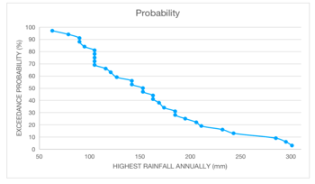
Figure 4: Nata’s peak rainfall excedence probability
The table contains rainfall data and Gumbel distribution formulas used to estimate flood magnitudes and frequencies. The rainfall data represents the maximum annual rainfall recorded over a certain time period in a specific region. The Gumbel distribution formulas are used to fit a probability distribution to the rainfall data and estimate the magnitude and frequency of floods of different return periods.
- Rainfall data: This column lists the maximum annual rainfall data for each year of the time period under consideration.
- Mean and standard deviation: These columns list the mean and standard deviation of the rainfall data, which are used to calculate the location and scale parameters of the Gumbel distribution.
- Gumbel distribution formulas: These columns list the formulas used to estimate flood magnitudes and frequencies of different return periods, based on the Gumbel distribution fitted to the rainfall data. The formulas typically include the Gumbel cumulative distribution function (CDF) and inverse CDF, which are used to estimate the probability of a flood of a given magnitude occurring in a given year, and the magnitude of a flood that is expected to occur once in a given return period (e.g., 10-year, 50-year, 100-year floods).

Table 3: Computation Table of Gumbel’s Extreme Value Distribution Method
YEAR | Precepitation | Rank(m) | P=m/(N+1) | T=1/P | Precepitation | Probability
1997 | 300.59 | 1 | 0.03 | 32 | 300.59 | 3.13
2018 | 295.31 | 2 | 0.06 | 16 | 295.31 | 6.25
2008 | 284.77 | 3 | 0.09 | 10.7 | 284.77 | 9.38
2000 | 242.58 | 4 | 0.13 | 8 | 242.58 | 12.5
2009 | 232.03 | 5 | 0.16 | 6.4 | 232.03 | 15.63
2011 | 210.94 | 6 | 0.19 | 5.3 | 210.94 | 18.75
2001 | 205.66 | 7 | 0.22 | 4.6 | 205.66 | 21.88
2021 | 195.12 | 8 | 0.25 | 4 | 195.12 | 25
1996 | 184.57 | 9 | 0.29 | 3.6 | 184.57 | 28.13
2017 | 184.57 | 10 | 0.31 | 3.2 | 184.57 | 31.25
2020 | 174.02 | 11 | 0.34 | 2.9 | 174.02 | 34.38
2013 | 168.75 | 12 | 0.38 | 2.7 | 168.75 | 37.5
1998 | 163.48 | 13 | 0.41 | 2.5 | 163.48 | 40.63
2007 | 163.48 | 14 | 0.44 | 2.3 | 163.48 | 43.75
2014 | 152.93 | 15 | 0.47 | 2.1 | 152.93 | 46.88
2016 | 152.93 | 16 | 0.5 | 2 | 152.93 | 50
2004 | 142.38 | 17 | 0.53 | 1.9 | 142.38 | 53.13
2005 | 142.38 | 18 | 0.56 | 1.8 | 142.38 | 56.25
2012 | 126.56 | 19 | 0.59 | 1.7 | 126.56 | 59.38
1991 | 121.29 | 20 | 0.63 | 1.6 | 121.29 | 62.5
2002 | 116.02 | 21 | 0.66 | 1.5 | 116.02 | 65.63
1993 | 105.47 | 22 | 0.69 | 1.45 | 105.47 | 68.75
1994 | 105.47 | 23 | 0.72 | 1.39 | 105.47 | 71.88
1999 | 105.47 | 24 | 0.75 | 1.3 | 105.47 | 75
2006 | 105.47 | 25 | 0.78 | 1.28 | 105.47 | 78.13
2010 | 105.47 | 26 | 0.81 | 1.2 | 105.47 | 81.25
1995 | 94.92 | 27 | 0.84 | 1.2 | 94.92 | 84.38
1992 | 89.65 | 28 | 0.88 | 1.14 | 89.65 | 87.50
2003 | 89.65 | 29 | 0.91 | 1.10 | 89.65 | 90.63
2015 | 79.1 | 30 | 0.94 | 1.1 | 79.1 | 93.75
2019 | 63.28 | 31 | 0.97 | 1.0 | 63.28 | 96.88
- Conclusion
The successful application of the Gumbel distribution method in predicting flood causing rainfall frequency and probability within the Nata basin using historical rainfall data represents a significant achievement in hydrological analysis. This study unveiled valuable insights into the past and potential future behaviour of floods causing rain in the region, offering a solid foundation for informed decision-making and flood risk management.
The historical rainfall data revealed necessary information about extreme rainfall events in the Nata basin. Specifically, the maximum annual rainfall of 301 mm recorded in 1997 and the second-highest peak of 295 mm in 2018, they demonstrate the variability and significance of precipitation in this area. The Gumbel distribution analysis, yielding an impressive R-squared (R²) value of 0.9618 and minimal pattern scatter, underscores the appropriateness of this statistical model for characterising extreme events.
Moreover, the derived trend line equation provides actionable insights for future flood preparedness and infrastructure planning. The estimates of projected river floods, such as the expected rainfall peaks of 205 mm over the next 10 years and 263 mm over the next 100 years, serve as valuable benchmarks for long-term planning and risk assessment. The estimation of a return period of roughly 2.1 years highlights the recurrent nature of floods in the Nata basin.
The findings affirm the validity and reliability of the Gumbel distribution method when applied to historical data from the Nata basin. This method has proven its worth as a tool for understanding and quantifying flood risk in places where river flow is unknown, ultimately contributing to the region's resilience in the face of natural disasters.
Looking ahead, future research should consider expanding the application of the Gumbel distribution method to different geographical regions with varying climatic conditions. Comparative studies that evaluate the performance of the Gumbel distribution against alternative methodologies for flood risk estimation would provide valuable insights into its generalizability.
References
- Gorata Samuel. “ Flood risk assessment for pro-active response to flood disasters in gaborone, botswana”. MSc Dissertation. University of Zambia, Zambia, 2021
- El-Jabi, Nassir. “Flood plain management : hydro-economic analysis”. Ottawa : Environment Canada. 1982
- Liew, Y.S.; Mat Desa, S.; Md. Noh, M..N.; Tan, M.L.; Zakaria, N.A.; Chang, C.K.”Assessing the Effectiveness of Mitigation Strategies for Flood Risk Reduction in the Segamat River Basin, Malaysia.” Sustainability, 2021, 13, 3286. https://doi.org/10.3390/su13063286
- N. Bhagat. “Flood Frequency Analysis Using Gumbel's Distribution Method: A Case Study Of Lower Mahi Basin, India”. Journal Of Water Resources And Ocean Science, 2017, vol 6, pp. 51-54.
- Arora, V. K. “Flood Frequency Analysis Using the Gumbel Distribution”. Engg Journals Publications. 2004
- United Nations Environment Program. APELL and Floods A community-based approach for disaster reduction. 2004 (http://www.unep.org/resourceefficiency/Portals/24147/scp/sp/publications/brochures/pdf/APELL-Floods.pdf) Accessed 22/10/2022.
- Fevzi, C., & Tamer, A. “Flood Frequency Analysis Using the Gumbel Distribution”. Semantic Scholar. 2015
- Central Statistics Office. Natural Disaster Digest 2010 . Gaborone: Central Statistics Office. 2010.
- Gumbel, E. J. “Statistical theory of extreme values and some practical applications”. National Bureau of Standards Applied Mathematics Series, 1954, 33, 1-78.
- Ouarda, T. B. M. J., El Adlouni, S., Bobée, B., & Zhang, X. “Comparison of annual maximum series and partial duration series methods for modeling peak flows under stationary and nonstationary assumptions”. Water Resources Research, 2006, 42(2).
- Sreedevi, P. D., & Rao, P. S. “Gumbel’s extreme value distribution for analysis of floods”. Indian Journal of Science and Technology, 2010, 3(2), 236-240.
- Xu, Y., Chen, X., Wang, J., & Chen, L. “Analysis of flood frequency based on the Gumbel distribution in the Yangtze River Basin, China”. Natural Hazards, 2012, 62(3), 1263-1272.
- Yazdi, J., Pourghasemi, H. R., Mahmoodian, S., & Zeinivand, H. “Flood frequency analysis using Gumbel and Log Pearson type III distributions in the Karoon River basin, Iran”. Natural Hazards, 2018, 93(1), 373-394.

